MSLD6D

Solar Lantern LED Driver and SMF Battery Charger with PWM Dimming, mobile phone charging

|  |  |
| --- | --- |
| naming.png | **Product Features**   * High efficiency > 85% * PWM Dimming * Battery reverse discharging protection * LED charging indicator * Battery over voltage protection * Best suited for commercial 6V SMF solar charged lanterns * Solder free design * Low cost   **Application**  MSLD6D is a high efficiency LED driver with SMF battery charging for 6V SMF and efficient PWM Dimming control. It houses state of art protection circuits for Battery reverse charging, over voltage protection.  This is best suited for designing of Solar Lanterns, powered with 6V SMF battery. It can drive LED string with output power 1.5W to 2.4W |

Product Program

|  |  |
| --- | --- |
| Input Voltage | 6V SMF battery |
| Output Current | 400mA – 800mA |
| Output Voltage | 5.7 Volt at LED string |
| Output Power |  |
| Dimming Control | PWM Control |
| PWM switching freq. | 200 Hz |

Connectors

MSLD6D is designed for solder free, easy installation. Design includes following connectors

1. CN1: 2 pin relimate male connector for connecting Solar Panel
2. CN2: 2 pin relimate male connector for connecting Battery
3. CN3: 2 pin relimate male connector for connecting LED string
4. CN4: 5 pin relimate male connector for connecting potentiometer switch for PWM dimming control , fuse and power on/off switch
5. CN5: 2 pin relimate male connector for connecting LED charging indicator

Connector Type: Relimate

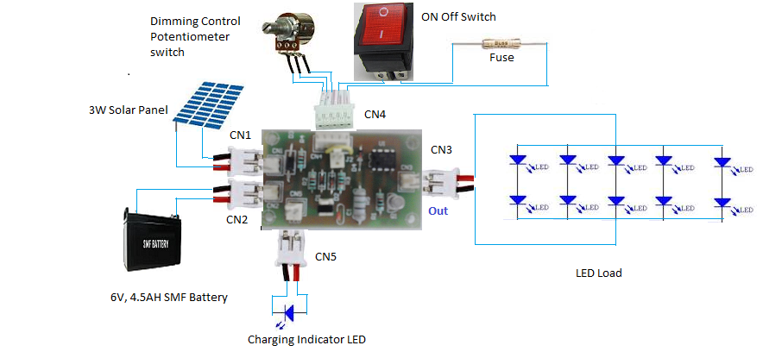

PCB Size/ Quality

MSLD6D is designed considering

* Compact PCB to fit properly in lantern designs
* Components sufficiently spaced for heat dissipation
* PCB is designed with high quality FR-4 material
* Connectors mounted on PCB are 2 pin and 5 pin relimate connector of 2.54 mm
* PCB size is 2.5 inch * 3 inch

Mobile Charging

Separate small PCB for mobile charger is available.

Details ---- XXX

Testing Details

**Test Setup**

MSLD6D is tested as Solar Lantern with following

|  |  |  |
| --- | --- | --- |
| LED Load | No of LED | 12 |
| Manufacturer | Nichia Corporation |
| Model | NESW157B |
| Forward Current Rating | 50 mA |
| Forward Voltage | Typ: 2.9V, Max: 3.1V |
| View Angle | 120 degree |
| Luminance | 6.1 Candella |
| Battery | Manufacturer | Amptek |
| Type | SMF(Rechargeable) |
| Nominal Voltage | 6 |
| C20 Rating | 4.5AH |
| Photo Voltaic Panel | Manufacturer | Maharishi Solar Technology |
| Model | MS B06 |
| Max Power | 3 Watt |
| Voc | 10.5 V |
| Isc | 0.44 amps |
| Vmp | 8.2 V |
| Imp | 0.36 amps |
| LED hosting | Cover | Two transparent glass |
| Outer Glass | XXXX |
| Inner Glass | XXXX |
| LED Strips | 3 |
| No of LED per strip | 4 |
| LED electrical connections | 6 parallel array of LED’s. Each array contains 2 LEDs in series |

**Test Results**

|  |  |  |
| --- | --- | --- |
| **Test Name** | **Test Description** | **Test Results** |
| Lux Measurement | Lux is measurement of illuminance. It measures luminous flux per unit area | |  |  |  | | --- | --- | --- | | **Distance** | **Horizontal** | **Vertical** | | 1 feet | 48 | 120 | | 2 feet | 8 | 44 | | 3 feet | 4 | 24 | | 4 feet | 2 | 12 | | 5 feet | 1 | 9 | |
| Duty Cycle | Average hours lantern should operate in a day, under average insolation of 5.5 kWh/sqm on a horizontal surface | 5 hours |
| Discharge Time | Discharge time of fully charged battery by continuous operation of Lantern | 18 hours |
| Charging Time | Time required to fully charge battery using solar panel with following insolation | |  |  | | --- | --- | | **Insolation** | **Time to charge** | | **-** | **-** | | **-** | **-** | |

About Moxie Devices

Moxie Devices is a professionally managed company engaged in the designing, manufacturing, distribution and export of Solar energy and LED based Products for various applications. Our products exemplify TQI (Technology, Quality and Innovation). Our products are known for their enormous energy efficiency and reliable performance.

Our focus is to provide environmentally conscious solutions by creating products that are designed to meet unique customer needs and protect the environment for today and for the future.Moxie Devices is a professionally managed company engaged in the designing, manufacturing, distribution and export of Solar energy and LED based Products for various applications. Our products exemplify TQI (Technology, Quality and Innovation). Our products are known for their enormous energy efficiency and reliable performance

Information furnished is believed to be accurate and reliable. However, Moxie Devices Pvt. Ltd assumes no responsibility for the consequences of use of such information nor for any infringement of patents or other rights of third parties which may result from its use. No license is granted by implication or otherwise under any patent or patent rights of Moxie Devices Pvt. Ltd. Specification mentioned in this publication are subject to change without notice. This publication supersedes and replaces all information previously supplied. Moxie Devices Pvt. Ltd products are not authorized for use as critical components in life support devices or systems without express written approval of Moxie Devices Pvt. Ltd.

Moxie Devices Logo is a trade mark of Moxie Devices Pvt. Ltd.

Printed in India – All rights reserved